**EXPERIMENT- 1A**

**AIM**

Create a Company table and answer the following questions 1. List the records in the company table orderby salary in ascending order. 2. List the records in the company table orderby salary in descending order. 3. Display only those employees whose age is 25. 4. List the name and sum of salary from company table group by name. 5. List the records in the company table where age should be >=25 and salary >=45000. 6. List the records in the company table where age should be >=25 or salary >=6500.

**CODE**

CREATE TABLE COMPANY(Id integer PRIMARY KEY, Name text,Age number, Address text, Salary number);

INSERT INTO COMPANY VALUES(1,'PAUL',32,'CALIFORNIA',20000);

INSERT INTO COMPANY VALUES(2,'ALLEN',25, 'TEXAS',15000);

INSERT INTO COMPANY VALUES(3, 'TEDDY',23,'NORWAY',20000);

INSERT INTO COMPANY VALUES(4,'MARK',25,'RICHMOND',65000 );

INSERT INTO COMPANY VALUES(5,'DAVID',27,'TEXAS',85000);

INSERT INTO COMPANY VALUES(6,'KIM',22,'SOUTHHALL',45000);

INSERT INTO COMPANY VALUES(7,'JAMES',24,'HOUSTON',10000);

COMMIT;

SELECT * FROM COMPANY ORDER BY SALARY ASC;

SELECT * FROM COMPANY ORDER BY SALARY DESC;

SELECT * FROM COMPANY WHERE AGE=25;

SELECT NAME, sum(SALARY) FROM COMPANY GROUP BY NAME;

SELECT * FROM COMPANY WHERE AGE>=25 AND SALARY>= 45000;

SELECT * FROM COMPANY WHERE AGE>=25 AND SALARY>=6500;

**OUTPUT SCREENSHOT**

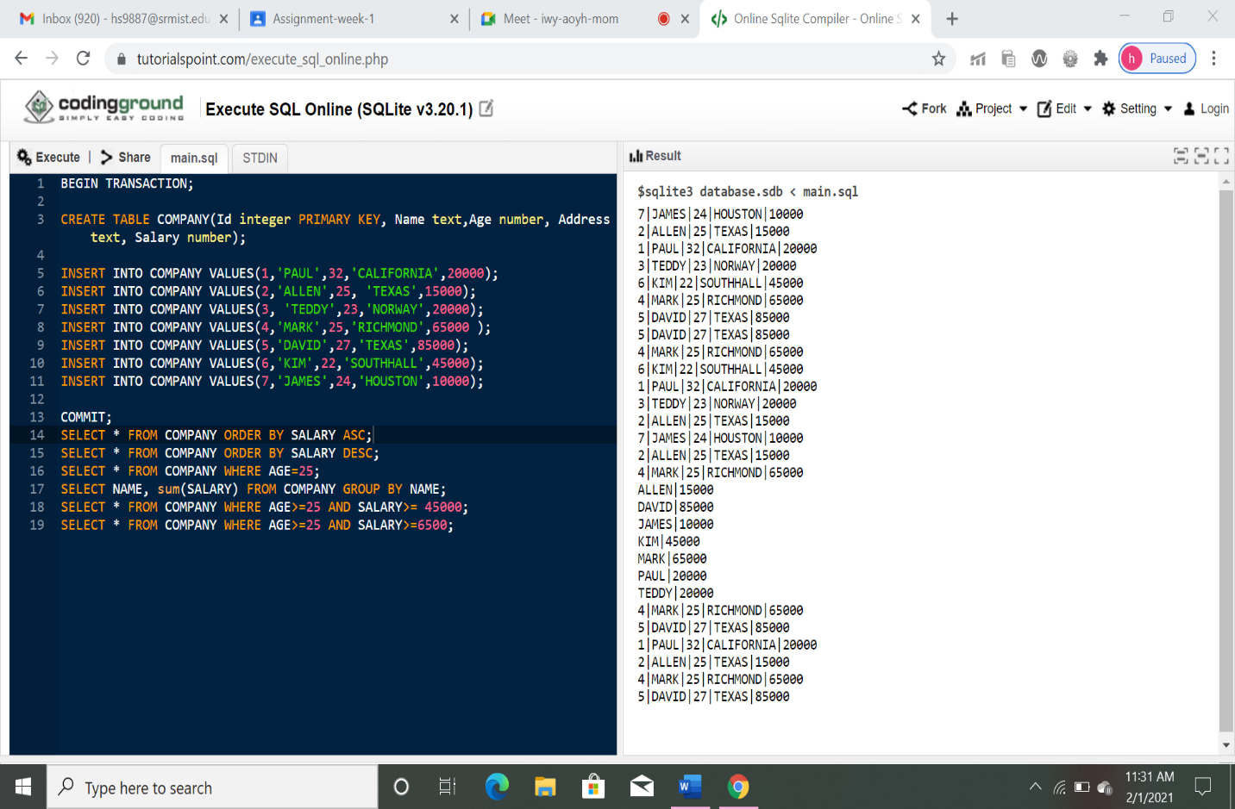

**RESULT**

The aim of the experiment to create the company table and execute the six queries was successfully executed on SQL online editor.